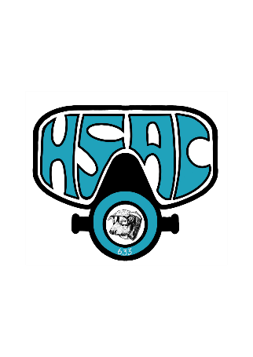
Headquarters:
Hereford Sub Aqua Club
The Rowing Club
Greyfriars Avenue
Hereford
HR4 0BE

Tel: 01432 273915
Try Dive

Entry Requirements
Minimum age 10 years, in good health, able to swim, have parental consent if under 18 years old.

All diving equipment will be provided, but you will need to bring swimwear, a T-shirt to wear in the water and a towel. Lockers are provided and require a £1 coin, which you get back.

Enrolment
I would like to take part in an Experience Scuba course on a date to be agreed. Payment is £30 per person which can be paid directly into the HSAC account:

Name HEREFORD SUB AQUA Sort code 53-50-41 acct 01048902 use your name and ‘try dive’ as the ref, e.g. J Bloggs Try Dive

Or you can bring with you on the night cash or a cheque made payable to Hereford Sub-Aqua Club (HSAC).

Please fill in your details below (block capitals)

Name: _______________________________________________________________

Address: ______________________________________________________________________

Post Code: ___________________ Telephone number: ___________________________________

Email: _________________________________________________________________________

If under 18 years: Parent / Guardian name:___________________

Parent / Guardian signature: ________________

If over 18 years:

I consent to photographing and/or videoing my involvement at the Try Dive and for any photos to be emailed to me and/or put on the club’s website & Facebook page:

Signature: ___________________________

